Screenshot of building images using docker

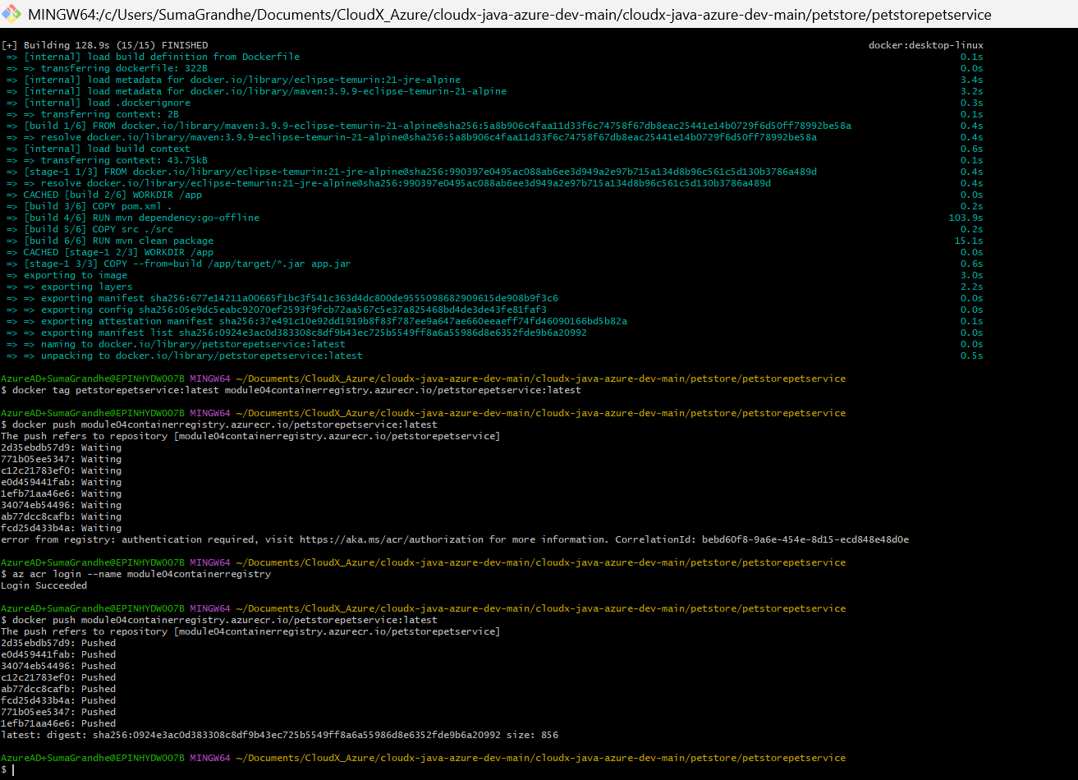

**1.Deploy Services to Azure Container Apps**

Screenshots of the configuration process for ProductService

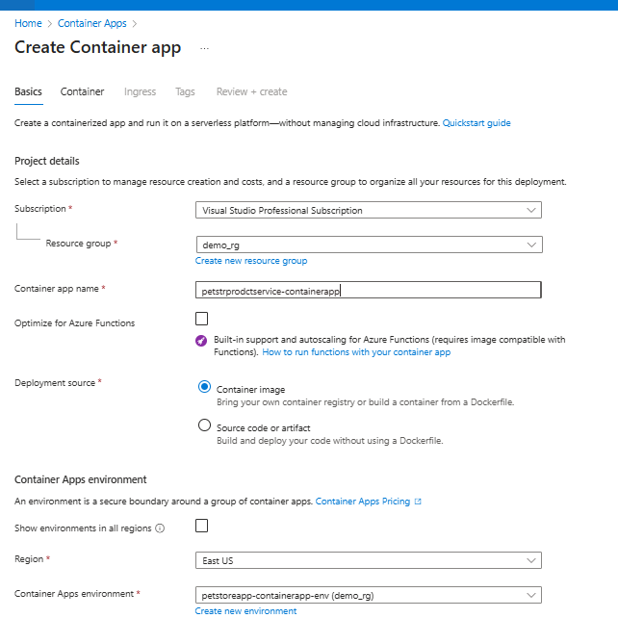

Screenshots of the configuration process for OrderService

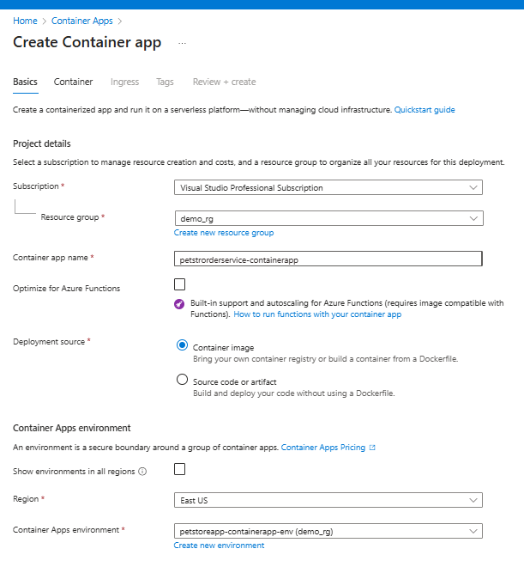

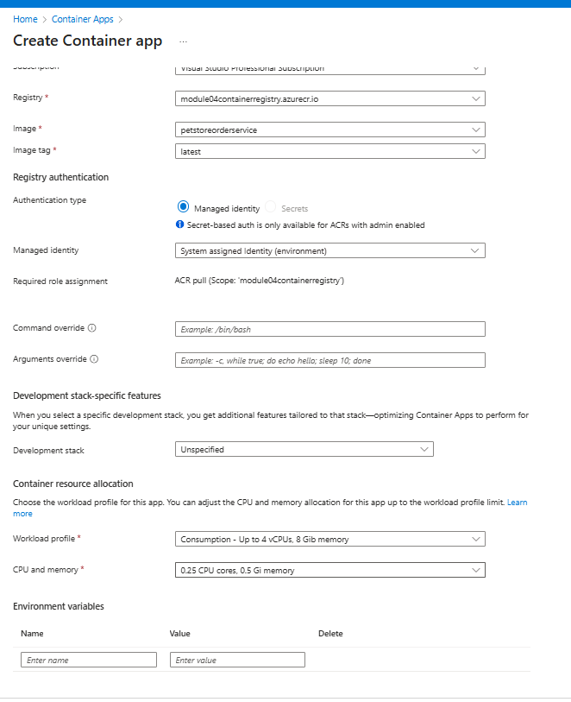

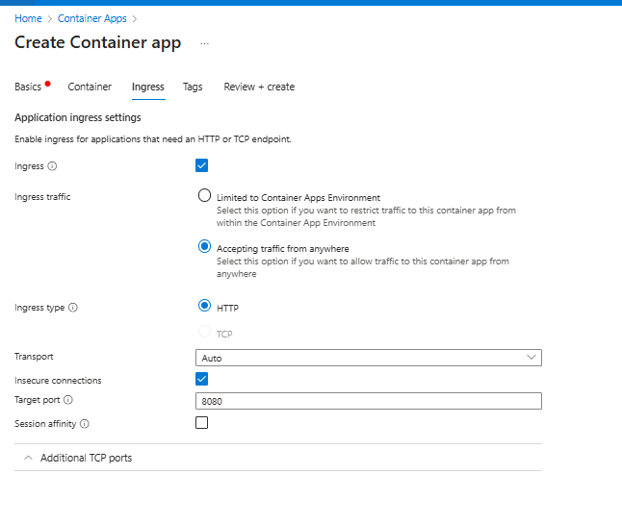

Screenshots of the configuration process for PetService

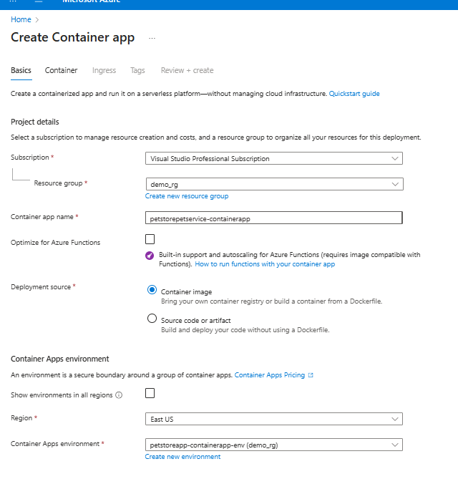

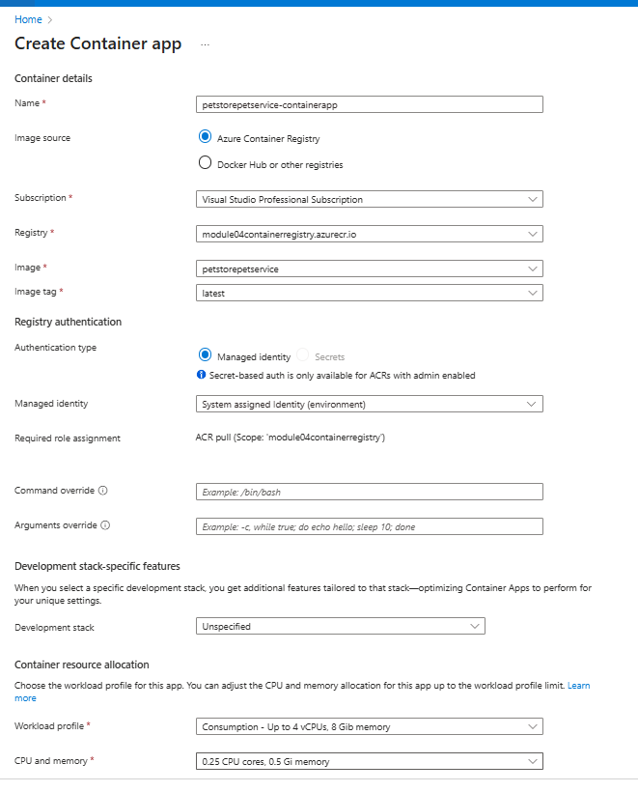

Screenshots of the configuration process for PetStoreApp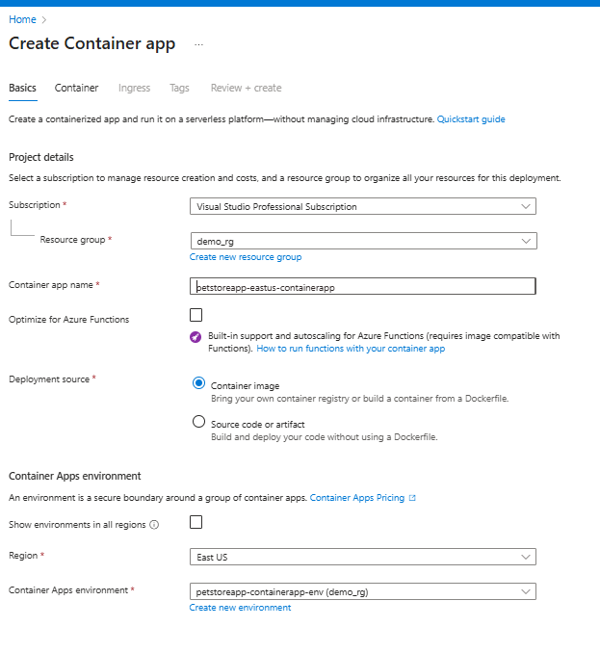

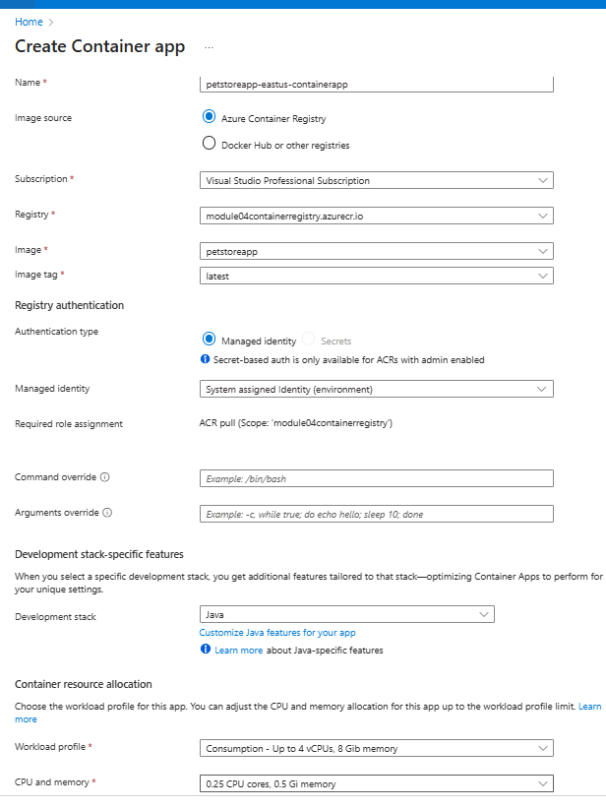

Screenshot showing the successful creation of each Container App instance.

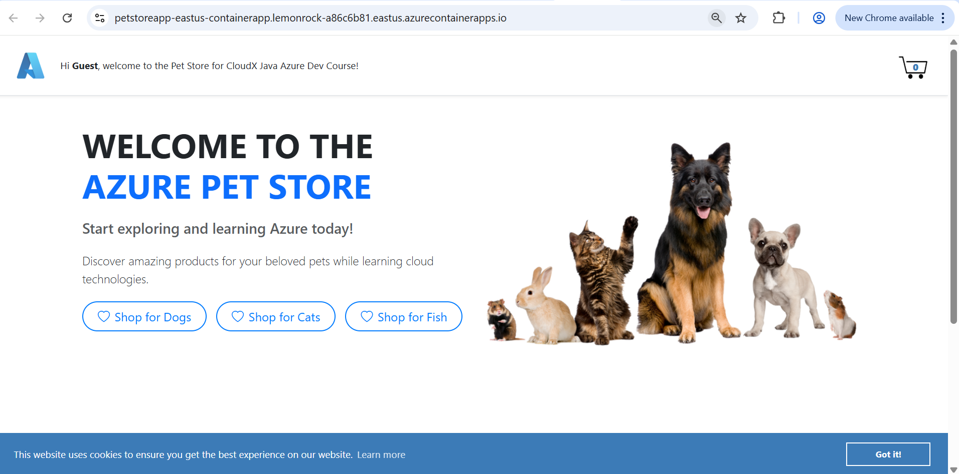

2.Configure Environment Variables

Screenshots of the Application URLs from the "Overview" tab.

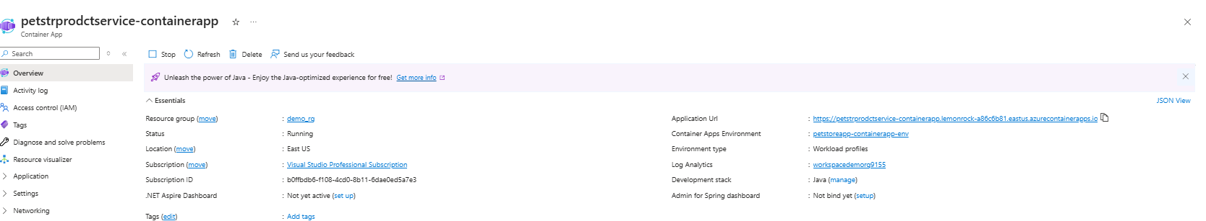

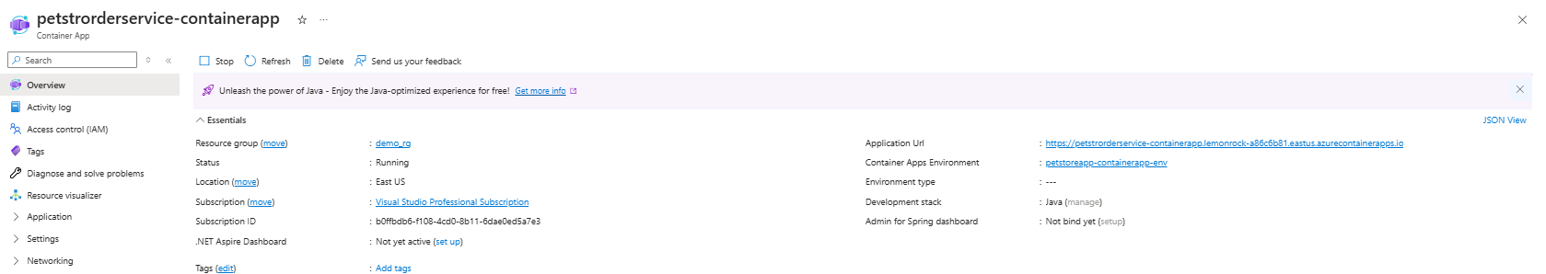

Screenshots showing the process of adding environment variables in the "Environment Variables" section

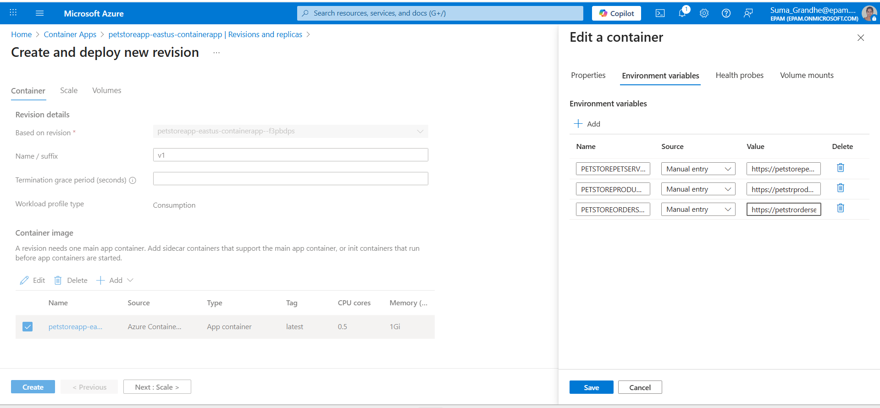

Screen recording showing the navigation between pages.



**3.Configure Autoscaling**

Screenshots of the "Scale and replicas" settings and "Add scale rule" configuration for HTTP scaling and concurrent requests settings for PetStoreApp

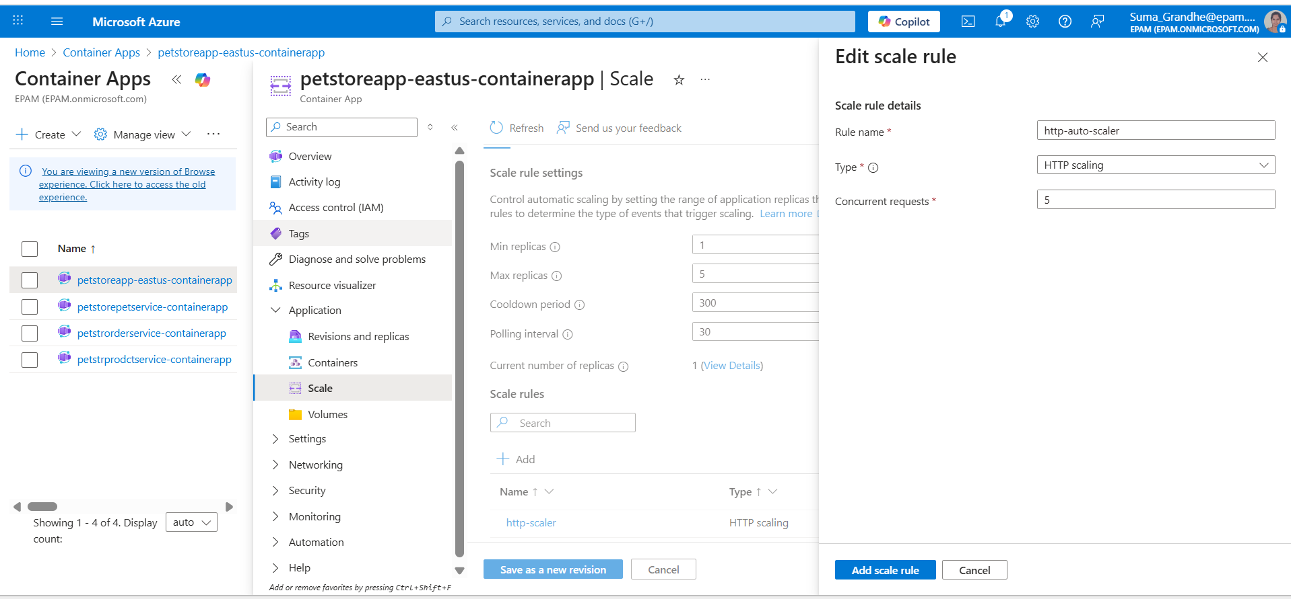

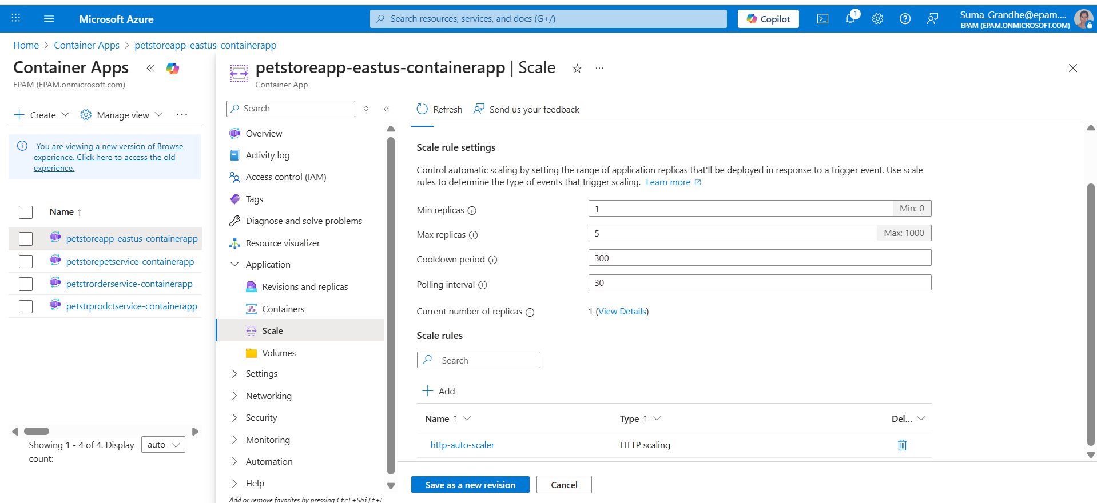

Screenshots of the "Scale and replicas" settings and "Add scale rule" configuration for HTTP scaling and concurrent requests settings for PetService

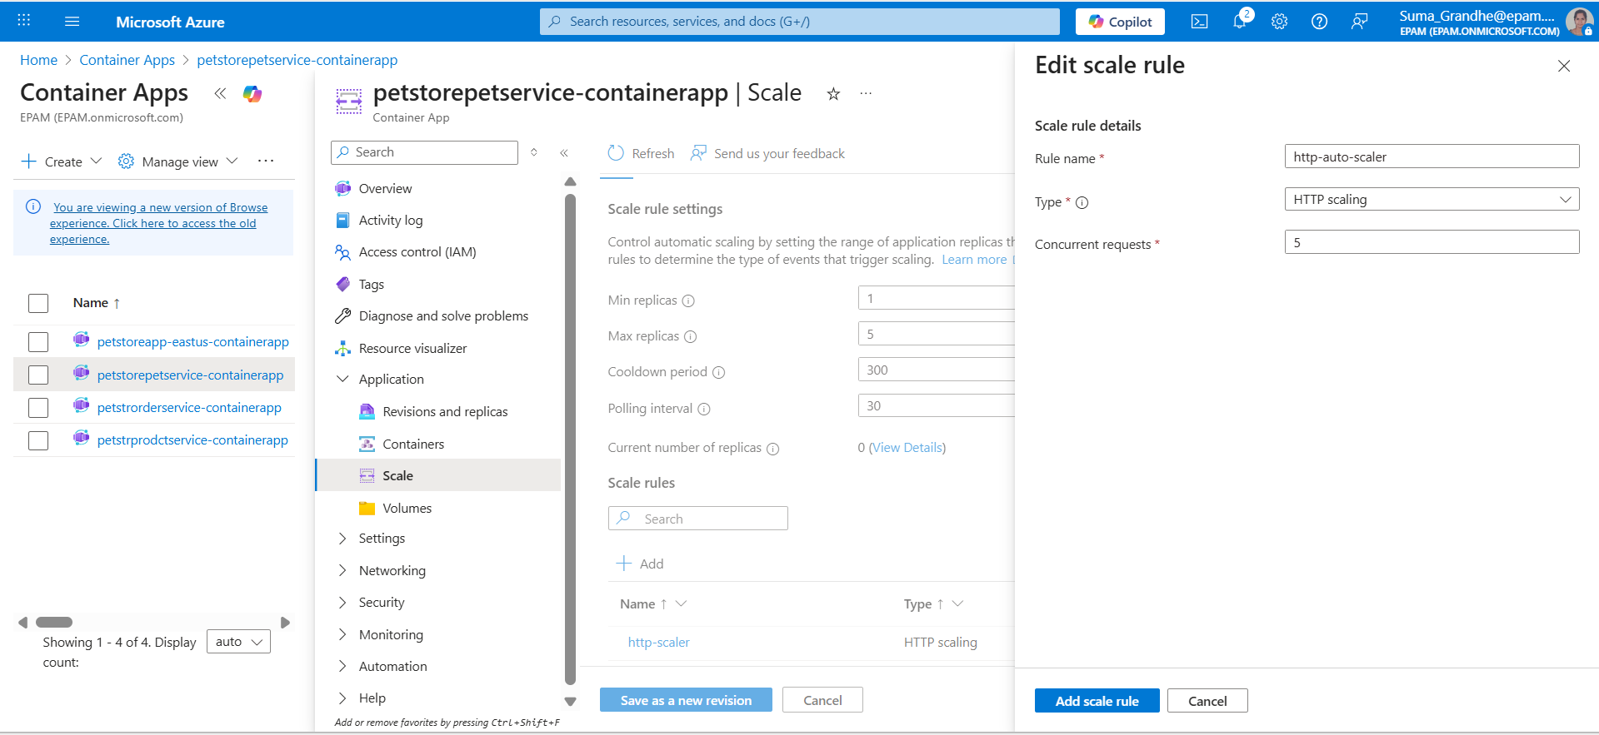

Screenshots of the "Scale and replicas" settings and "Add scale rule" configuration for HTTP scaling and concurrent requests settings for OrderService

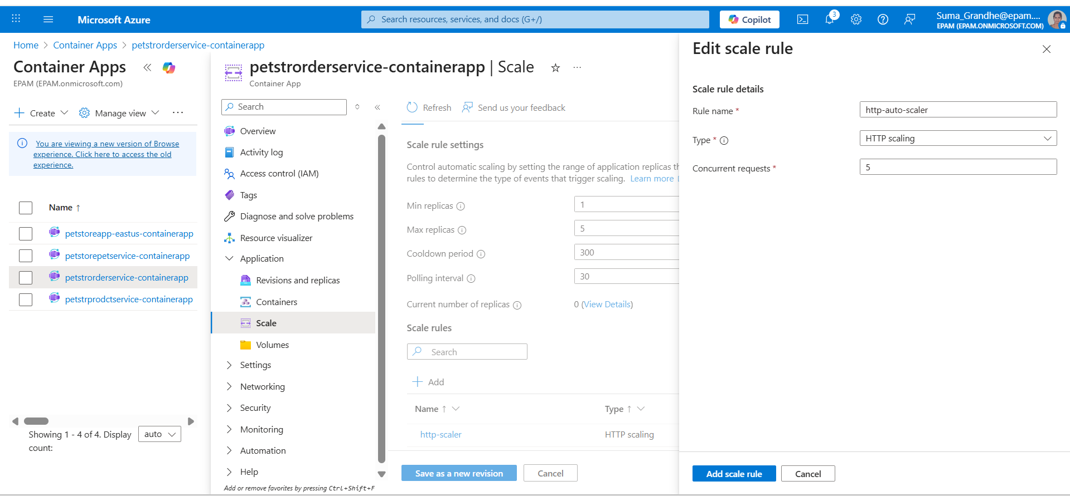

Screenshots of the "Scale and replicas" settings and "Add scale rule" configuration for HTTP scaling and concurrent requests settings for ProductService

**4.Test Autoscaling using k6 Tool**

Screenshots of Swagger endpoints utilized for testing autoscaling and k6 tool in use for testing autoscaling and showing the scaling behaviour under load.

**5.Deploy Multiple Revisions Simultaneously for PetStoreApp**

Screenshot showing the "Revisions" settings with "Multiple" selected as the Revision Mode for the PetStoreApp.

Screenshots of the "Create new revision" process, including updating the container image tag and the creation of the new revision

Screenshots showing the traffic distribution settings under "Active revisions" for Canary deployment.

**Screenrecording showing the canary deployment**



Endpoint pointing towards revision 1

Endpoint pointing towards revision 2

Endpoint pointing towards Application URL

Screenshots of the final traffic distribution settings for Blue/Green deployment, with 100% traffic directed to the new revision.

Screen recording showing the blue green deployment



A screenshot showing the list of Azure resources that correspond to the diagram

